Task Title
S3 Static Website Hosting with Route 53 and CloudFront CDN

Objective
To host a static website using Amazon S3, deliver content globally using CloudFront CDN, and map a custom domain using Route 53.

Prerequisites
- AWS account
- Registered domain in Route 53
- Static website files (index.html)
- Basic AWS permissions (S3, CloudFront, Route 53)

Step-by-Step Implementation
Step 1: Create S3 Bucket
- Console Path: AWS Console → S3 → Create bucket
- Create an S3 bucket and enable Static Website Hosting.
Step 2: Upload Website Files
- Console Path: S3 → Bucket → Upload
- Upload index.html and other static files and allow public access.
Step 3: Create CloudFront Distribution
- Console Path: CloudFront → Create Distribution
- Set S3 bucket as the origin to enable CDN.
Step 4: Configure Route 53
- Console Path: Route 53 → Hosted Zones → Create Record
- Create an A (Alias) record pointing to the CloudFront distribution.

Validation Steps
- Website is accessible using CloudFront URL
- Website is accessible using custom domain name
- DNS resolution works correctly (nslookup domain-name)

Issues Faced (Optional)
- Access denied error from S3
- Resolved by updating bucket policy and public access settings

Conclusion
The static website was successfully deployed using S3, integrated with CloudFront CDN, and mapped to a custom domain using Route 53.

1. Enable cloudtrail monitoring and store the events in s3 and cloudwatch log events.
Now login aws console and serach CloudTrail then click
Now click on create trail
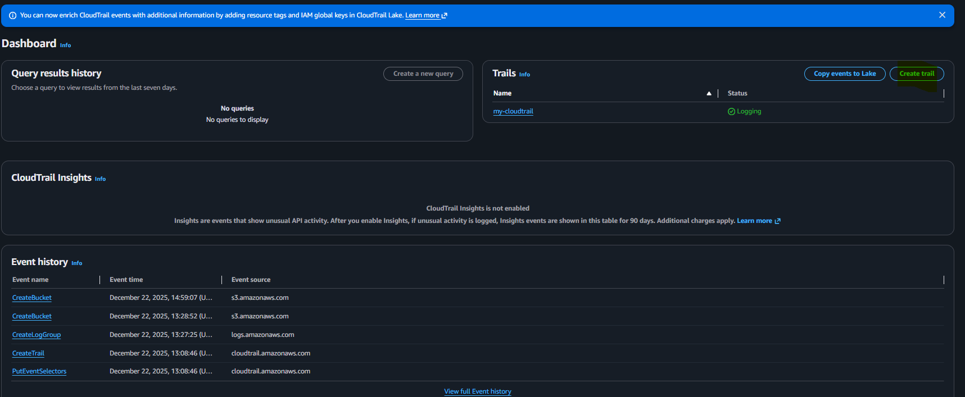
Now write it name provide details on it after that click next
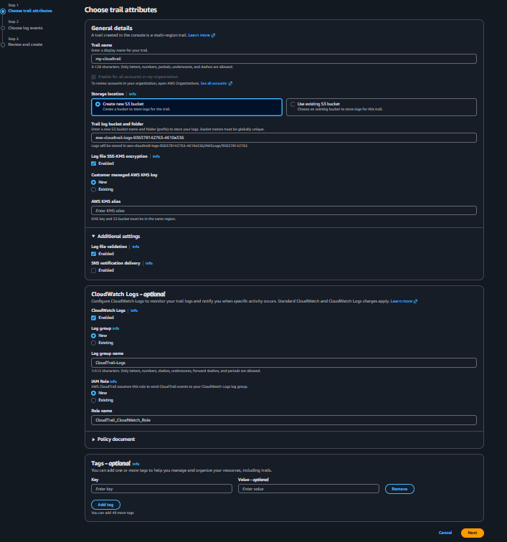
Now click on choose log even ticket and leave it defult
Then click on next

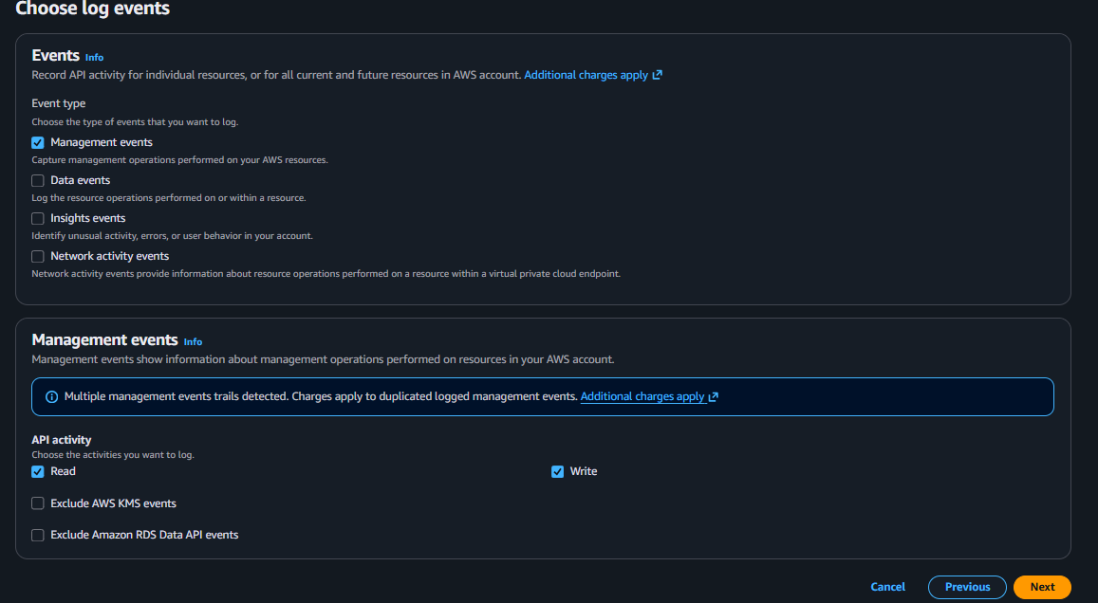

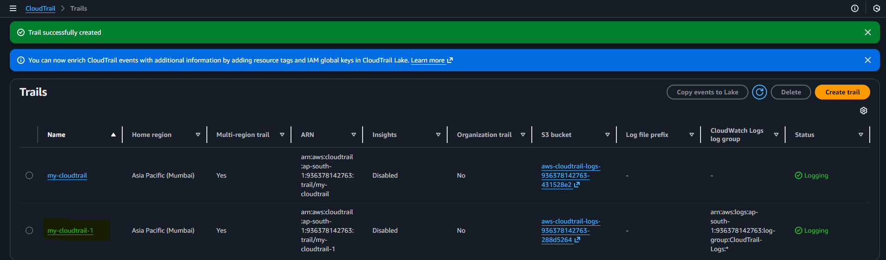
Now can conform it that create test bucket and delete it
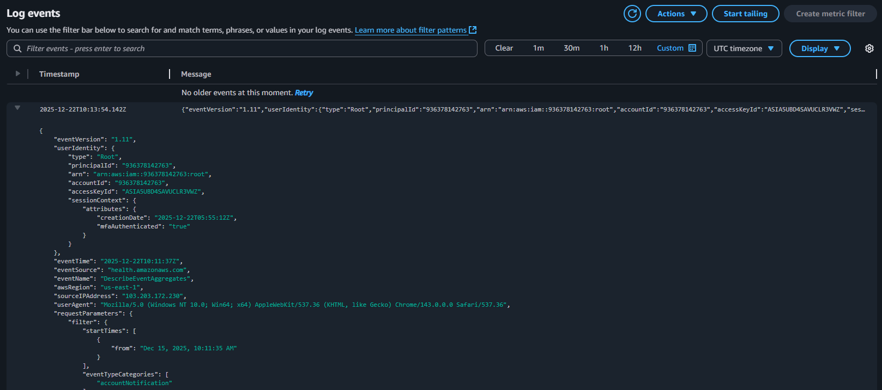
Issues Faced
• Initial "Insufficient Data" State: Upon creation, the
alarm did not immediately show "OK" or "In Alarm."

2. Enable SNS for cloudtrial to send alert on email.
Task Title
•SNS for CloudTrail to send alert on email
Objective
•To create a multi-region organizational trail that captures all account activities, stores them securely in S3, monitors them via CloudWatch, and triggers immediate email notifications via Amazon SNS whenever a log file is delivered.
Step 1 search aws console sns then click on it

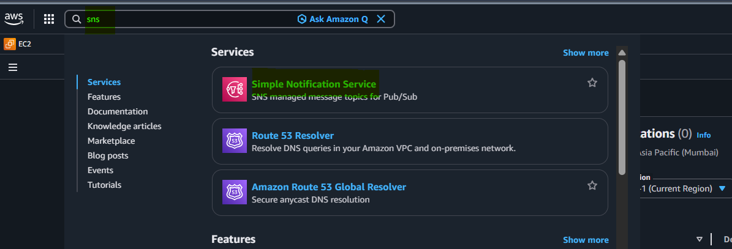
Now give your sns name and also optional display name then click on create topic
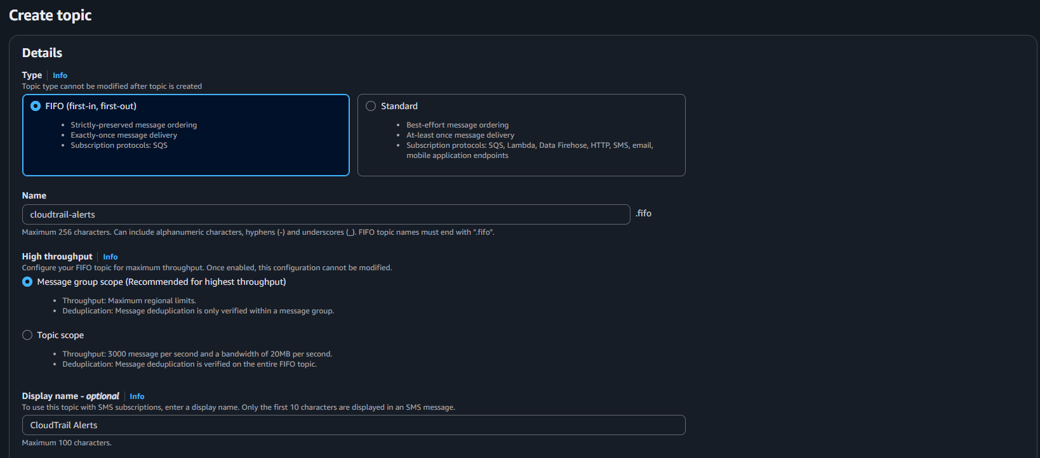

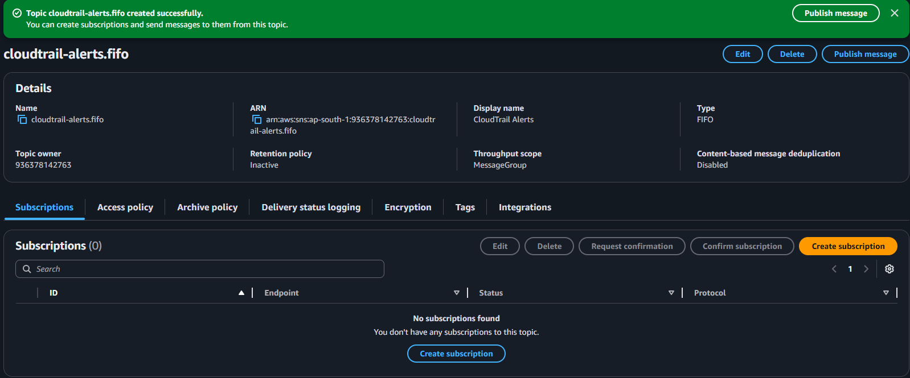
Ok now go create subscription write your email address

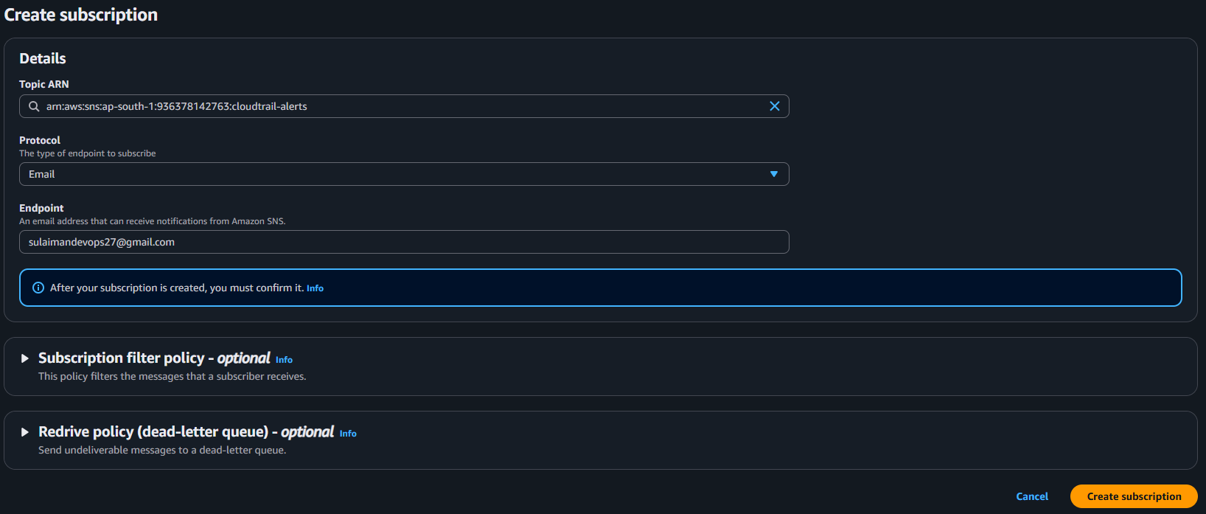

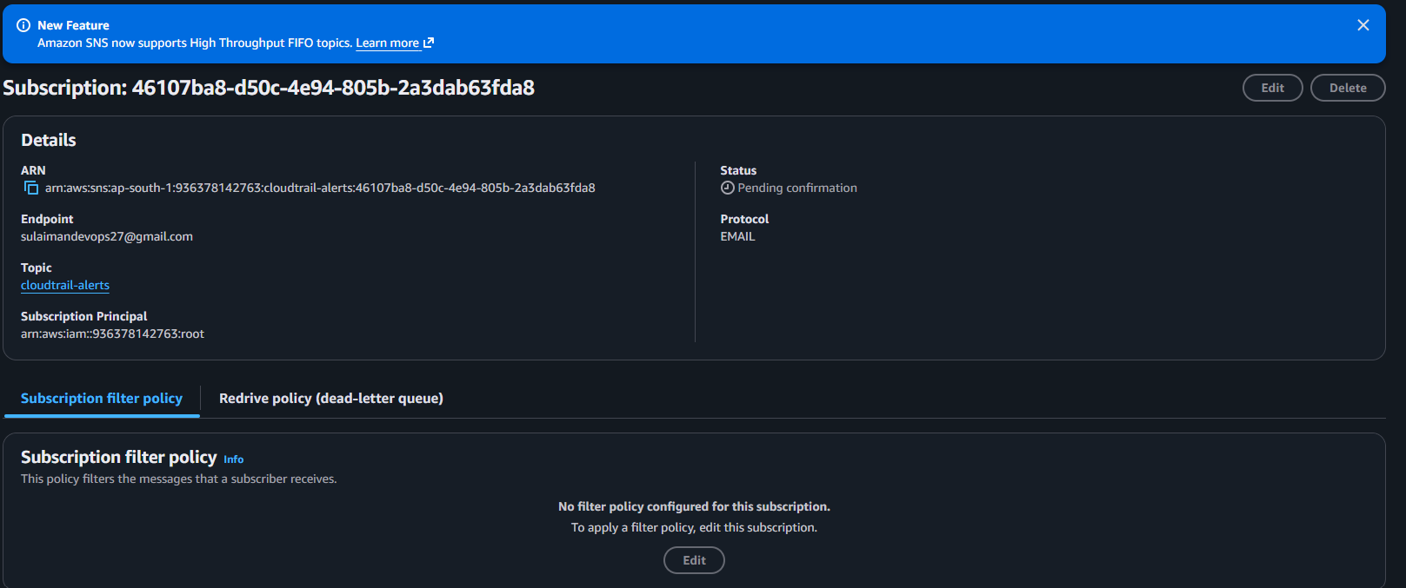
Now confirmed it
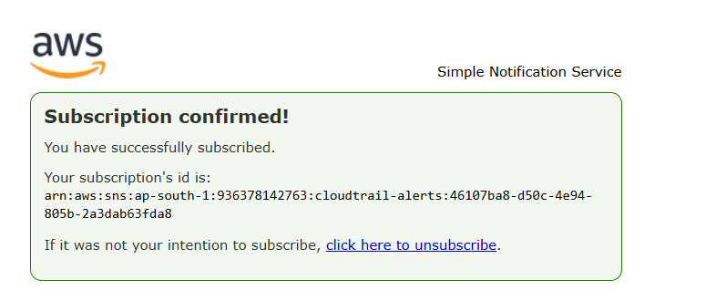
3) Configure cloud watch monitoring and record the cpu utilization and other metrics of ec2
Task Title
- Implementing Detailed Monitoring and Custom Dashboards for AWS EC2 Instances
Objective
- To enable high-resolution monitoring for an EC2 instance and consolidate critical performance metrics into a centralized CloudWatch Dashboard for real-time visibility.

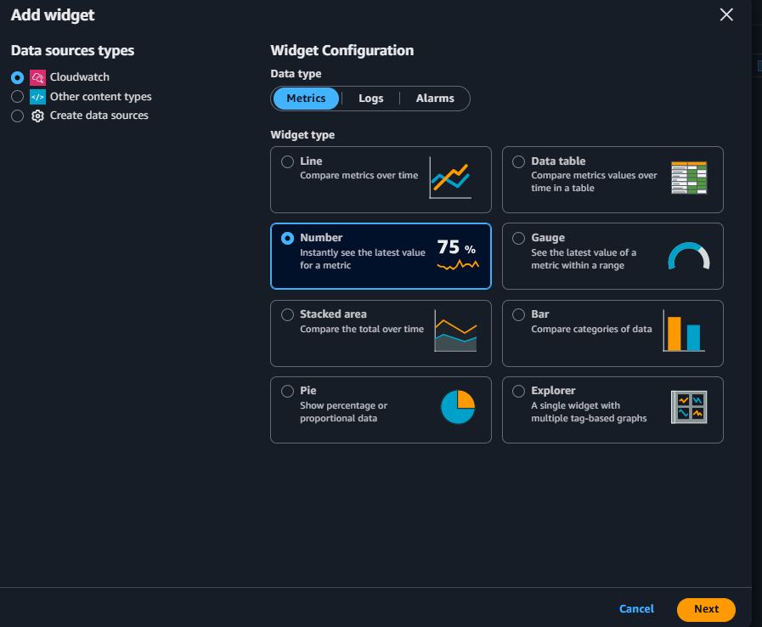
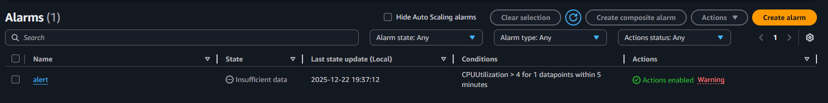
Now we have get alarm
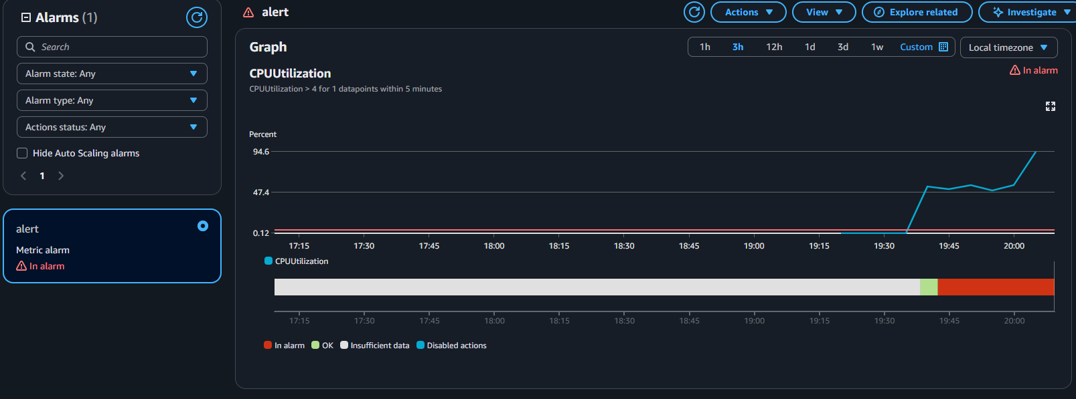

4. Create one alarm to send alert to email if the cpu utilization is more than 70 percent.
Task Title
- Monitoring EC2 Performance with CloudWatch Alarms and SNS Notifications
Objective
- To implement a real-time monitoring solution for an AWS EC2 instance that triggers an email notification via Amazon Simple Notification Service (SNS) whenever the CPU Utilization exceeds 70%.

Now click on create alarm
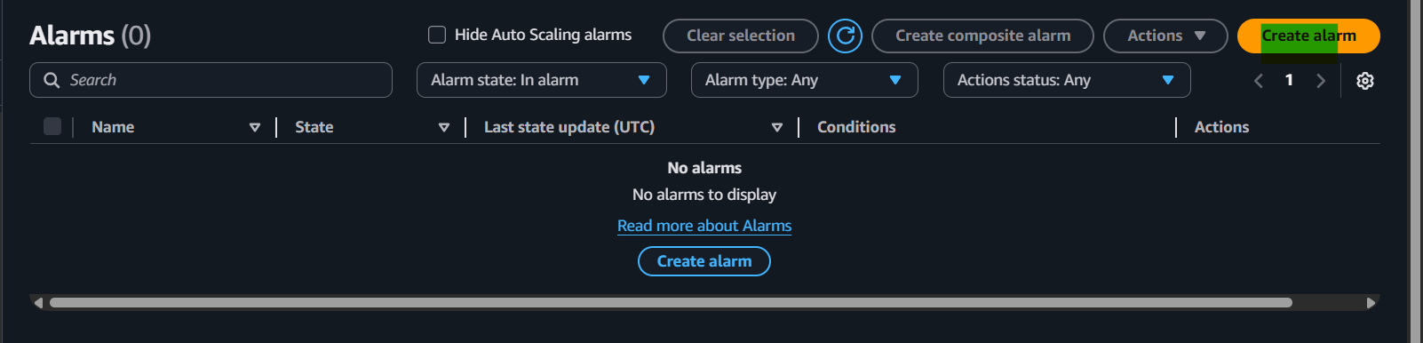
Now select ur id insantce matric name
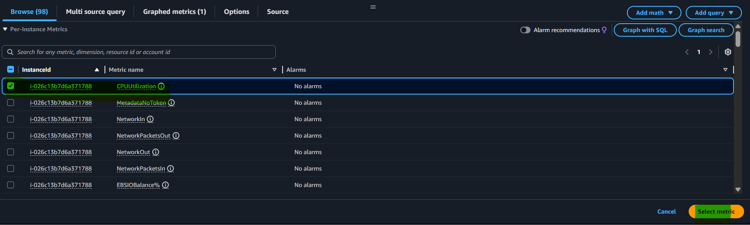

That’s it place of than.. define the therehold value you type percentage don’t mention 70% just wrute 70 then click on next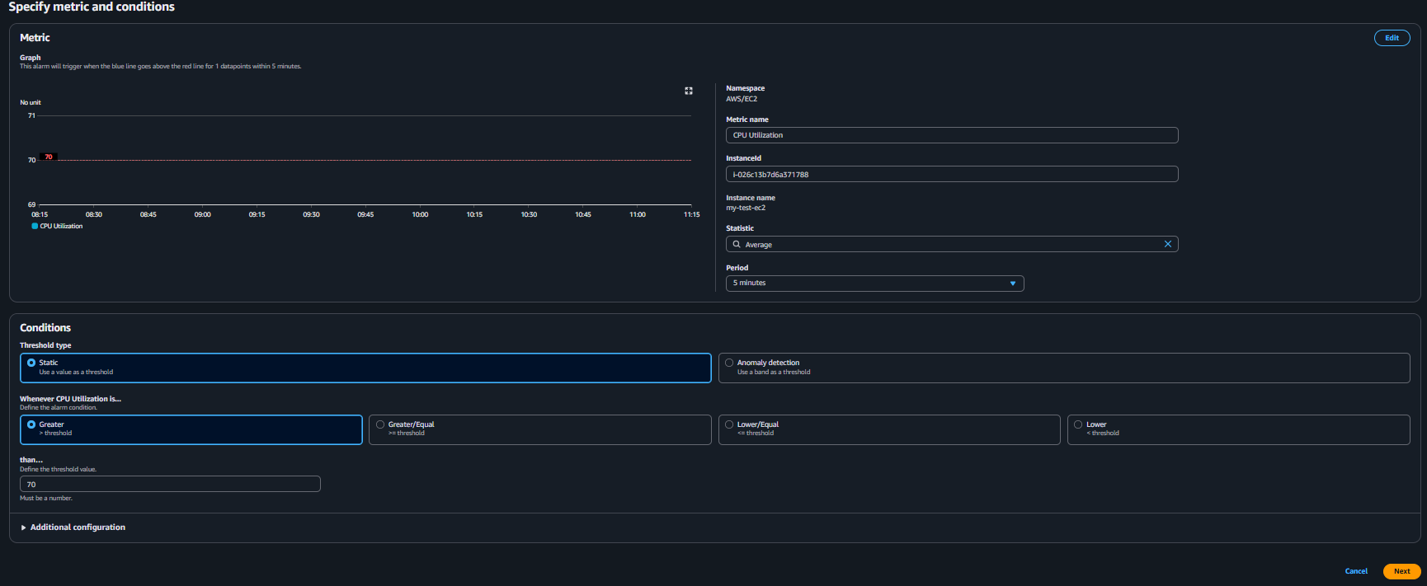
Now full fill detail email that’s it click on next
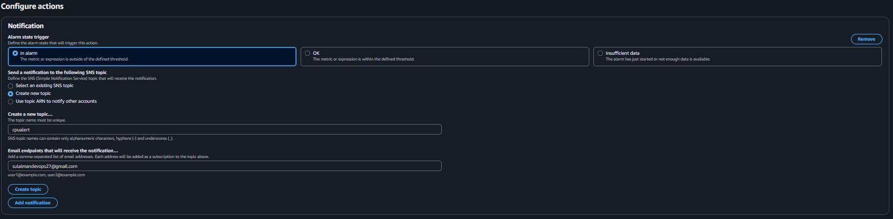
5. Create Dashboard and monitor Tomcat service (running or not) and send alert
Task Title
- Monitoring Tomcat Server Status with Custom CloudWatch Metrics
Objective
- To create a monitoring solution that tracks the availability of a tomcat9 service on an EC2 instance and triggers an automated alarm in Amazon CloudWatch if the service goes down.
Step 1: Monitor Tomcat Service with CloudWatch

AWS CloudWatch can monitor EC2 instances and services running on them. Tomcat doesn’t directly integrate with CloudWatch, so we need to push custom metrics.

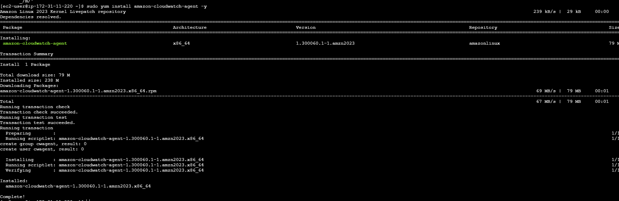
Create the Monitoring Script
Now paste your code in it
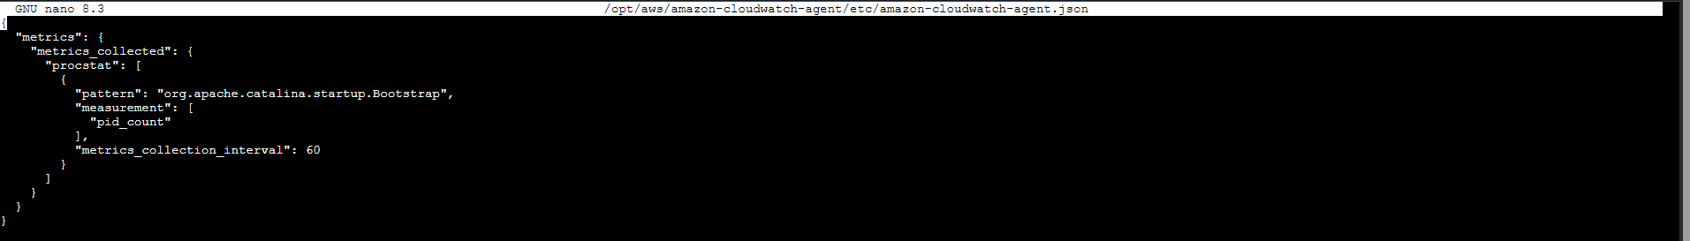
Now next script set your region and name
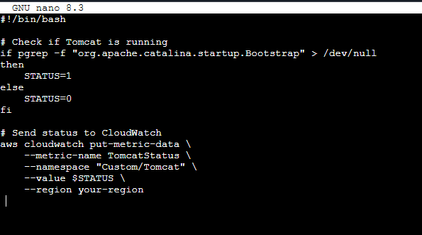
And last type ctrl+o enter ctrl x that’s it
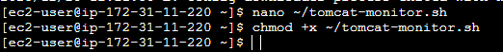

6) Create Dashboard and monitor nginx service to send the alert if nginx is
not running.
Task Title
Monitoring NGINX Server Availability Using AWS CloudWatch Dashboard and
Alarm with Email Notifications
Objective
To install and run an NGINX web server on an EC2 instance, monitor its
availability using a custom CloudWatch metric (nginx_status), visualize the
status on a CloudWatch dashboard, and configure a CloudWatch Alarm with
SNS email notification to alert when NGINX goes down. Make sure install nginx on machine

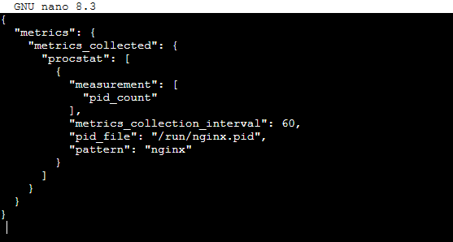
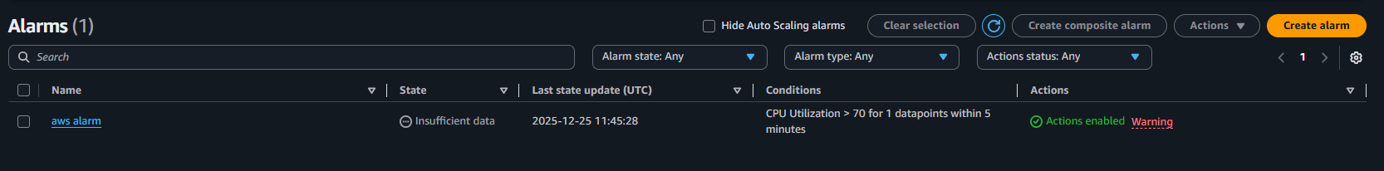
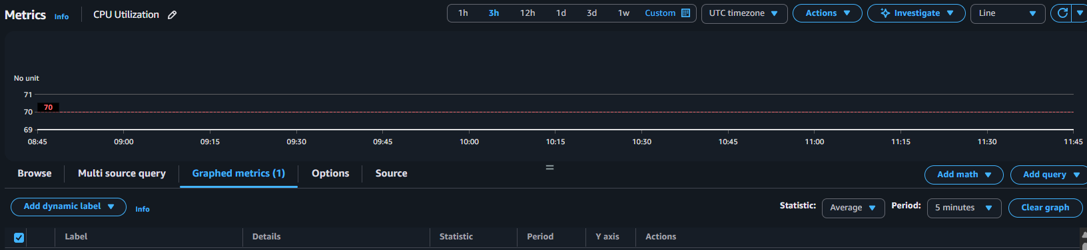
Optional Tip:
If you want a Bash script approach instead of CloudWatch Agent
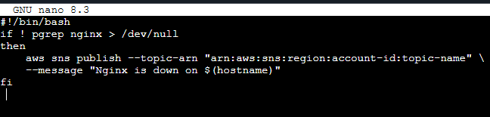
Issues Faced
The CloudWatch alarm for monitoring the Nginx service is triggering correctly in AWS, but the notification emails are not being received in the designated Gmail account.
Thanks for for a review my task logout….

